Superstore Sales Analytics

1. Project Overview

Explanation
The purpose of this project is to analyze Superstore sales data using Power BI and convert raw business data into meaningful insights. The dashboard helps stakeholders understand sales performance, profit trends, customer behavior, and regional contributions. Interactive visualizations enable users to make data-driven decisions quickly and effectively.

2. Dataset Description

Explanation
The Superstore dataset contains transactional sales information from a retail business. It includes customer details, product categories, geographical locations, order dates, shipping details, sales revenue, discounts, quantity sold, and profit values.

Key Columns
- Order ID – Unique order number
- Order Date – Date of purchase
- Customer Name – Customer information
- Category – Product category
- Sub-Category – Product classification
- Sales – Revenue generated
- Profit – Profit earned
- Discount – Discount applied
- Region – Sales region
This dataset allows analysis of sales performance across products, customers, and locations.

3. Business Objectives

Explanation
The main objective of this analysis is to evaluate business performance and identify growth opportunities.

Objectives
- Measure overall sales and profitability.
- Identify top-performing products.
- Analyze customer segments.
- Compare regional performance.
- Understand discount impact on profit.
- Support strategic business decisions.

4. Data Preparation

Explanation
Before creating visualizations, the dataset was cleaned and transformed to ensure accuracy and consistency.

Steps Performed
- Imported CSV file into Power BI.
- Checked data types.
- Converted date columns.
- Removed duplicate records.
- Verified missing values.
- Renamed columns for clarity.
- Created relationships where necessary.
Data preparation improves dashboard reliability and ensures accurate reporting.

5. DAX Measures

Explanation
DAX (Data Analysis Expressions) measures were created to calculate key business metrics dynamically.

Measures Used
Total Sales
Total Profit
Total Orders
Profit Margin %
Shows profitability percentage.
These measures help track business performance in real time.

6. Dashboard Design

Explanation
The dashboard was designed using interactive visualizations to present information clearly and effectively.

Visuals Used

KPI Cards
Display:
- Total Sales
- Total Profit
- Total Orders
- Total Quantity
Purpose:
Provide a quick overview of business performance.

Line Chart
Shows monthly sales trends.
Purpose:
Identify seasonal patterns and growth trends.

Bar Chart
Displays sales by category and sub-category.
Purpose:
Compare product performance.

Map Visualization
Displays state-wise sales.
Purpose:
Understand geographical performance.

Pie/Donut Chart
Shows sales contribution by customer segment.
Purpose:
Identify major customer groups.

7. Key Insights

Explanation
Several important business insights were identified through the dashboard analysis.

Insights

Technology Category Leads Sales
Technology products generated the highest sales revenue among all categories.

Discounts Affect Profitability
Products with higher discounts often resulted in lower profits.

West Region Performs Best
The West region contributes significantly to both sales and profit.

Top Products Drive Revenue
A small number of products generate a large percentage of total sales.
These insights help management focus on profitable areas.

8. Business Recommendations

Explanation
Based on the analysis, the following recommendations are proposed.

Recommendations
- Reduce excessive discounts.
- Focus marketing efforts on profitable regions.
- Increase inventory for top-selling products.
- Promote high-margin products.
- Develop customer loyalty programs.
These actions can improve profitability and business growth.

9. Dashboard Design Best Practices

Explanation
Several dashboard design principles were followed to improve user experience.

Best Practices
- Consistent color theme.
- Clear visual hierarchy.
- Interactive slicers.
- Minimal clutter.
- Meaningful titles.
- Business-focused insights.
These practices improve dashboard readability and usability.

10. Conclusion

Explanation
This Power BI project successfully transformed raw sales data into actionable business insights. The dashboard enables decision-makers to monitor performance, identify opportunities, and make informed strategic decisions.
The analysis highlights the importance of product performance, customer behavior, regional trends, and profitability management in achieving business success.

11. Summary Storyboard (Final Presentation Slide)

Business Problem
The company needs a better understanding of sales and profitability performance.

Analysis Performed
Sales, profit, customer, product, and regional analysis were conducted using Power BI.

Key Findings
- Technology category leads sales.
- High discounts reduce profit.
- West region performs best.
- Top products generate significant revenue.

Recommended Actions
- Optimize discount strategy.
- Focus on profitable products.
- Expand high-performing regions.
- Improve customer retention.

Business Impact
The dashboard provides a single source of truth for monitoring business performance and supporting data-driven decisions.

Data Modelling
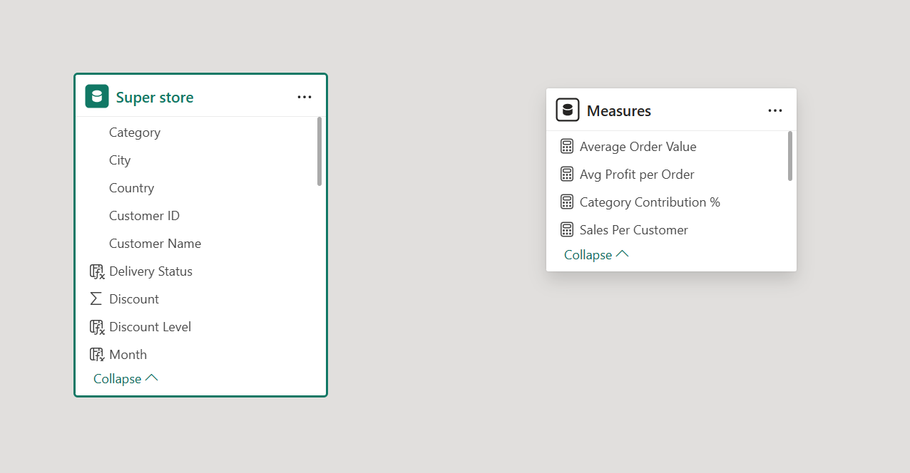
Dash Board
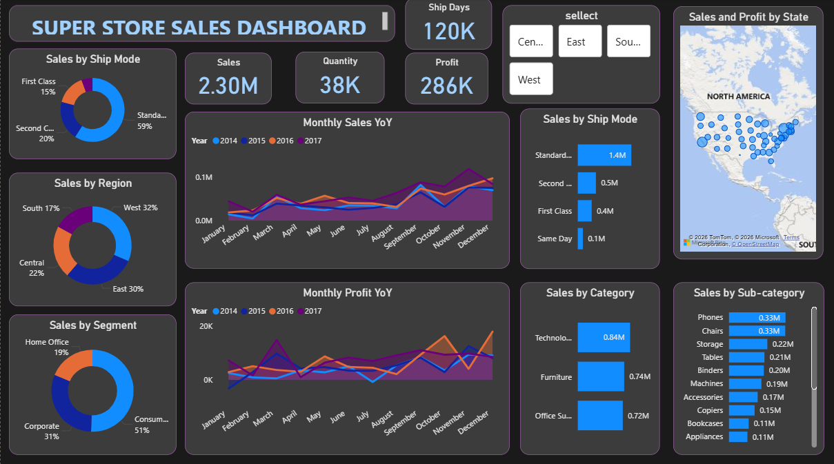
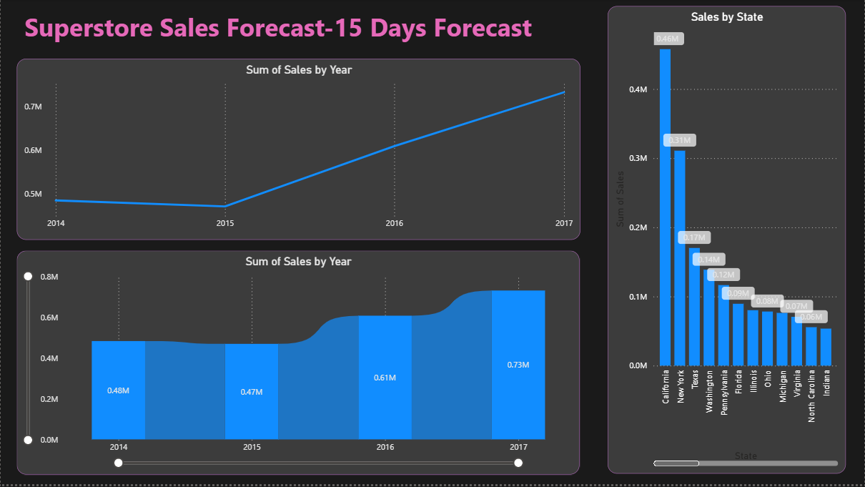

Story Board
